Images

Convert PowerPoint to PDF

categories."

Edit this text

Shipping Preferences by Segment



Superstores Sales Prediction Using Time Series Analysis

Anjad Mshrqi | Training and Competitions by Correlation One | Data Analysis & Visualization Specialist Explore the Interactive Dashboard: [superstore Tableau Dashord](https://public.tableau.com/views/SuperStores_17406077953270/SUPERSTORESSALESUSA?:language=en-US&publish=yes&:sid=&:redirect=auth&:display_count=n&:origin=viz_share_link)

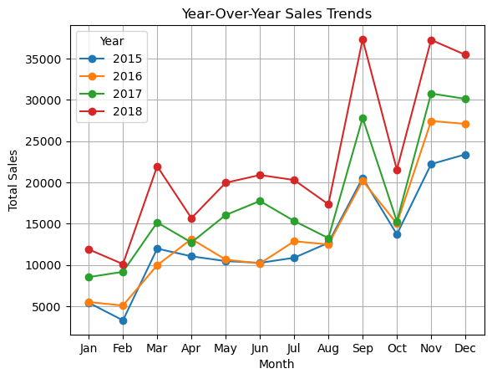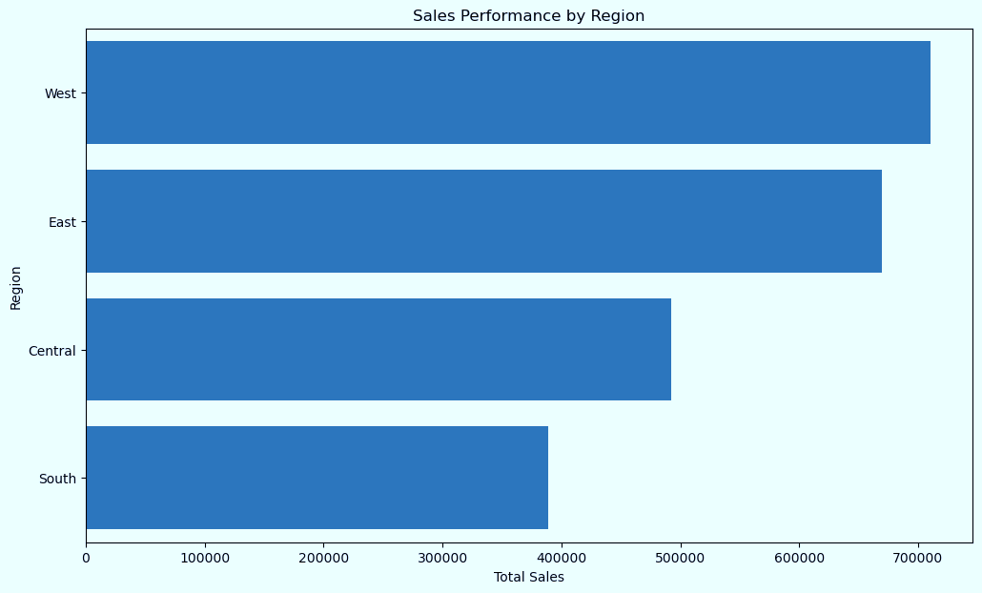

* Geographic Distribution of Sales

Overall sales have shown a steady upward trend from 2015 to 2018, with a significant peak in Q4 2018

**Analysis**

* Sales Trend over Time (2015-2018)]
* This analysis utilizes the Superstore sales dataset, a comprehensive record of transactions from 2015 to 2018, focusing on US market sales.
* Data cleaning and processing were performed using Python (version 3.10) with the Pandas (version 1.4.0) library (data manipulation). NumPy (version 1.22.0) (numerical operations) was used for array and matrix calculations. Visualization was achieved with Matplotlib (version 3.5.0) and Seaborn (version 0.11.2) (statistical visualization). The entire process was conducted within a Jupyter Notebook (version 6.4.8) environment managed by the Anaconda distribution (version 2022.05)

This Project is aim to analysis and explores key sales trends, identifies high-value customer segments, and analyzes product performance to inform strategic recommendations for increasing revenue and market

share.

**Data And Method**

●

**Business Context**

* Superstore, a national retail chain, is committed to driving sustainable sales growth in a competitive market. To achieve this goal, Superstore needs a deep understanding of its sales patterns, customer behavior, and product performance. .

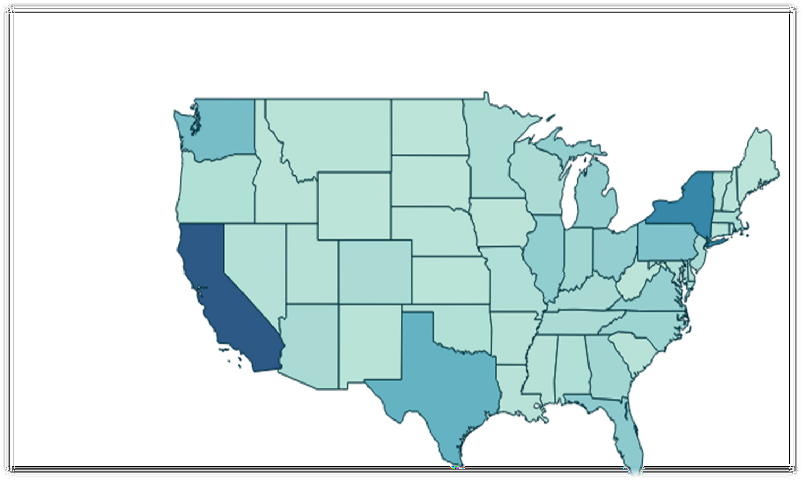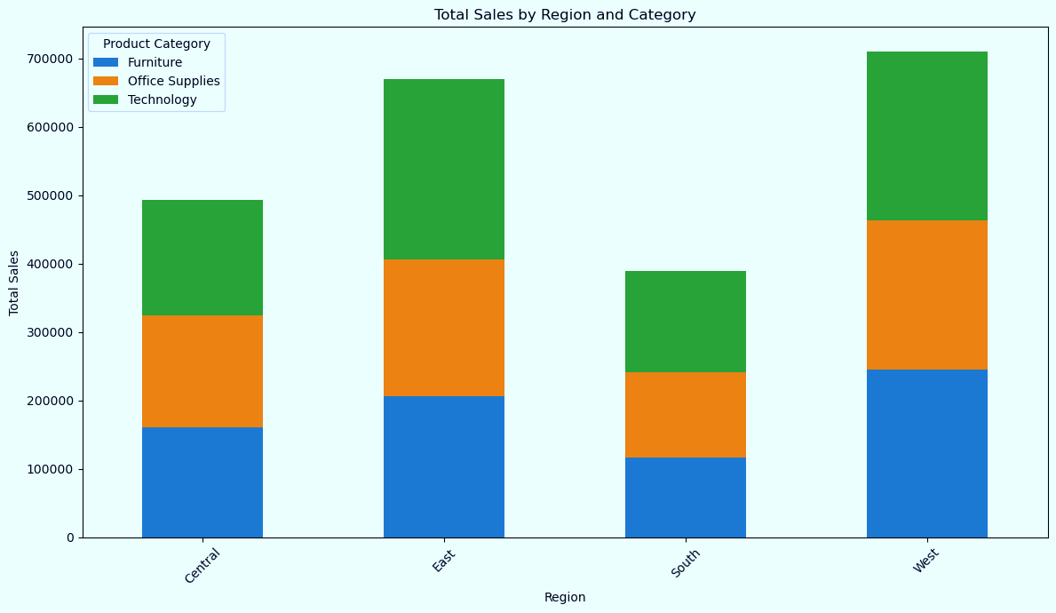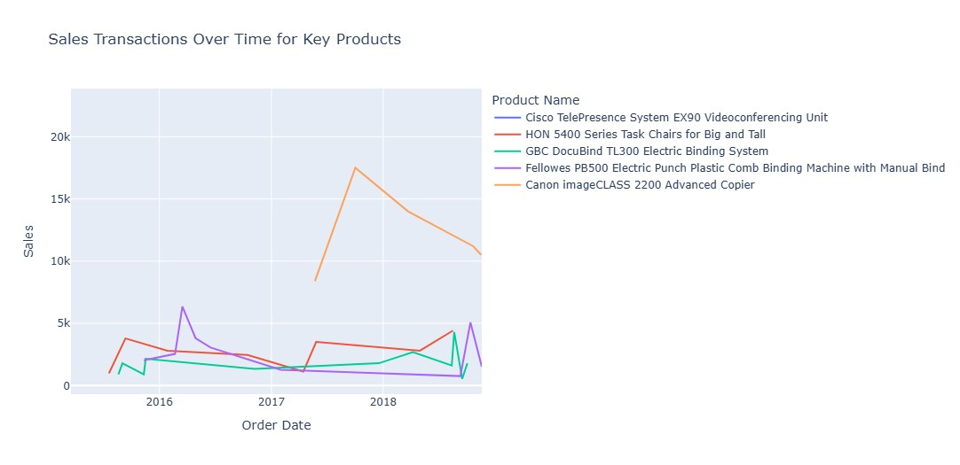

**Emphasizes Top Performers**

California and Texas lead in sales, demonstrating strong market

presence in key states

**Sales by Region and Product Category**

* The West region leads in sales across all product categories, particularly in technology 30% of Total Sales.
* The East region demonstrates a strong performance in the furniture category.
* Office supplies show a relatively consistent performance across regions,

but contribute a smaller proportion of sales compared to other

**Florida (2.5%)**

**Texas (4.5%)**

**California (14.5%)**

**Pennsylvani**a (4%)

**New York (9.6%)**

**Washington (4.2%)**

**Illinois (2.3%)**

This presentation poster was designed by Anjad Mshrqi.

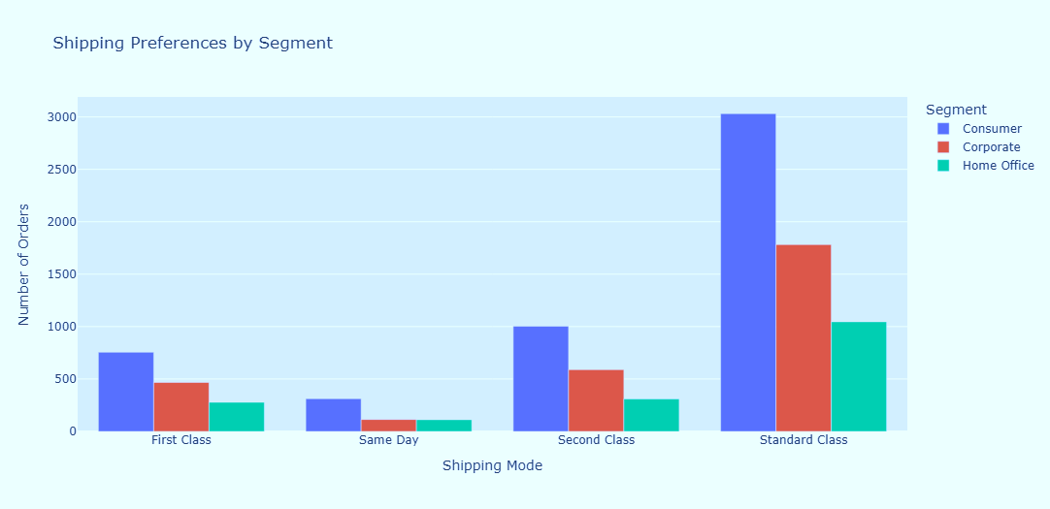

**Shipping Preferences by Segment**

* The Standard Class shipping mode is overwhelmingly preferred by all customer segments, particularly the corporate segment.
* While Standard Class is popular across segments, the corporate segment shows a higher preference for Second Class compared to other segments.
* The Consumer segment demonstrates a strong preference for Standard Class, followed by First Class.
* Same Day shipping is the least utilized across all segments
* Despite the availability of faster shipping options, Standard Class remains the most popular choice across all segments.

**Summary**

This analysis has demonstrated the importance of a data-driven approach to understanding sales patterns and driving sustainable growth for Superstore. We identified key regional disparities in sales performance, highlighting the strength of the West region and the need for improvement in the East. We also found that the Corporate segment is a crucial driver of revenue, and that technology products consistently outperform other categories. These findings provide Superstore with actionable insights to optimize sales strategies, improve profitability, and enhance customer satisfaction. Superstore should prioritize targeted marketing campaigns in the East region, focusing on the Corporate segment and promoting high-performing

technology products.

**Strategic Recommendations**

* **Targeted Marketing**: Implement a targeted marketing campaign in the East region, focusing on the corporate segment, to increase sales by 15% within the next quarter. Rationale: Sales in the East region are significantly lower than in the West, particularly within the Corporate segment, suggesting untapped potential for growth.
* **Loyalty Program**: Develop a loyalty program specifically tailored to the needs and preferences of the high-value corporate segment to improve customer retention by 10%. Rationale: The Corporate segment accounts for over 50% of total sales, making customer loyalty crucial for sustained revenue.
* **Office Supplies Review**: Conduct a thorough review of the office supplies product category, including pricing strategies, marketing campaigns, and product assortment, to address the declining sales trend. Rationale: Sales of office supplies have been steadily declining over the past four years, indicating a need for strategic

intervention.

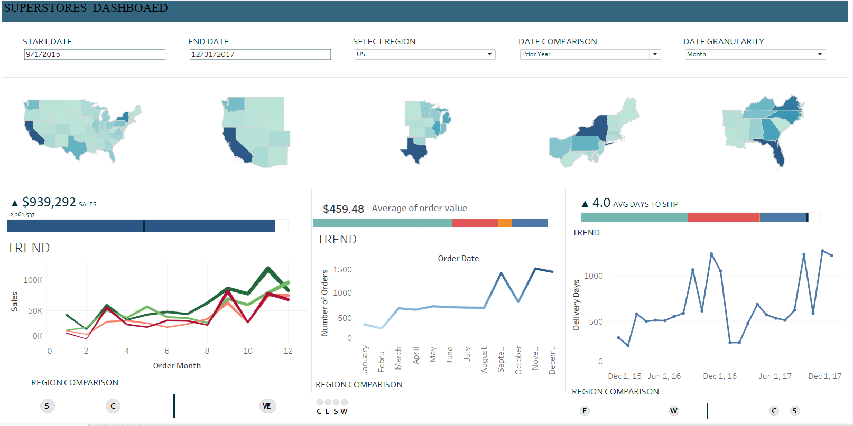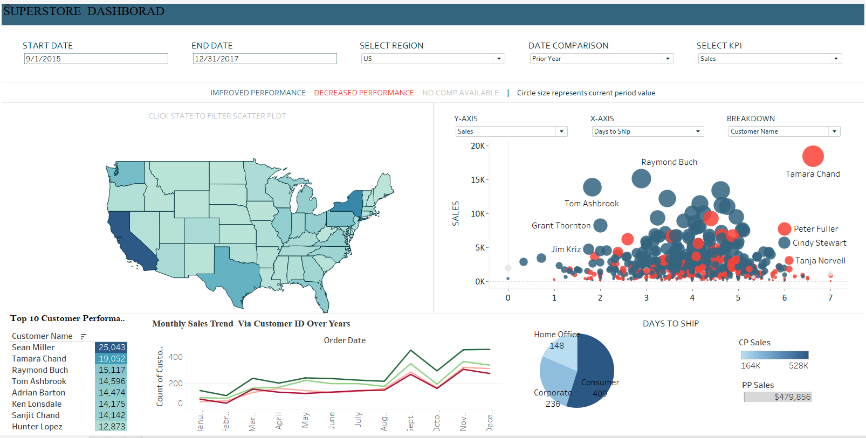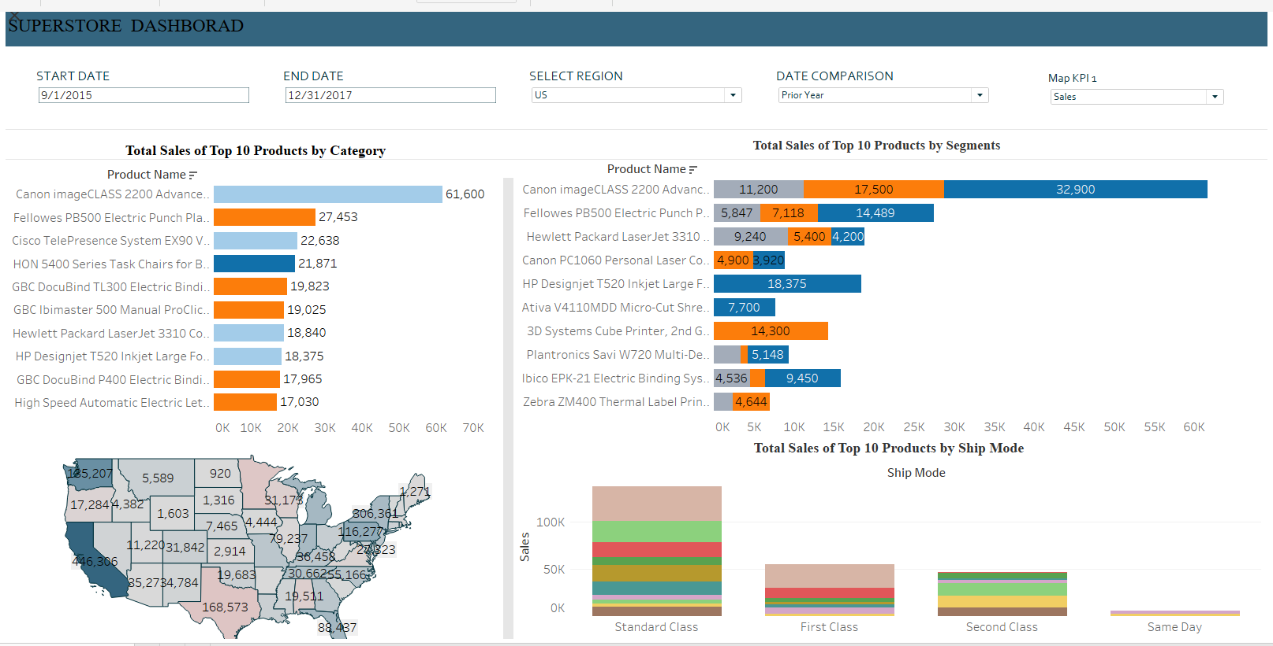

# To provide a dynamic exploration of the Superstore sales analysis, an interactive Tableau Public dashboard has been created. This dashboard offers a comprehensive view of key factors influencing Superstore's demographics, such as customer segments, shipping modes, product categories, states, cities, and sub-categories. The visualizations have been strategically chosen and arranged to maximize clarity and insight, ensuring that the data is presented in an intuitive and cohesive manner.

# The consistent color palette used throughout the datafolio is maintained in the dashboard to enhance visual appeal and coherence. This interactive tool allows users to delve deeper into the data, uncovering trends and patterns that inform strategic business decisions.

# The interactive dashboard is available at: [[Superstore Dashborad]](https://public.tableau.com/views/SuperStores_17406077953270/SUPERSTORESSALESUSA?:language=en-US&publish=yes&:sid=&:redirect=auth&:display_count=n&:origin=viz_share_link)



Superstores Sales Prediction Using Time Series Analysis

Anjad Mshrqi | Training and Competitions by Correlation One | Data Analysis & Visualization Specialist

